STOP TO SEE WHAT WE HAVE DONE,
THOUGH A LITTE EFFORT BUT WELL DONE

Stories of happy schools-action taken by ITA.

GGES Basti Dewala school Jalal Pur peer Wala, Multan.
Basti Dewala, a beautiful village in Jalal Pur, mesmerizing with the sweet smelling mango trees and a tract of cotton icebergs spread over acres of land.
One can’t imagine that such a beautiful village is deprived of education. There are two primary schools-one for girls and the other for boys. Girls schools were closed three years back when the only teachers got transfer near her home. She used to come from Multan and it was a long distance for her. After she left school, students kept on coming for a month and then the school was closed for good.
This school was the only hope for parents to get their children literate; after its closure they got just disappointment. School was a dream for children in this village. A child shared that he wanted to be a doctor but if there won’t be any school how he would become a doctor. The sad faces of children in the village, when asked about the school, were telling.
How children of the village were spending their time in the absence of school? It was life without any objective. Wandering in streets, playing all day was the only activity they could have. Many mothers were worried that the children could not read and write and that was highly alarming situation for them; at least they must read and write to be part of social stream.
But for three years nobody came to open and teach in the school. But finally god listened to prayers of villagers; ITA initiated CPB project and school was opened.Officilas both form ITA and Education department participated in the inaugural ceremony.
After ribbon cutting, I entered the school and tried my best to observe the condition of the school but could not concentrate as happiness and enthusiasm on the faces of children was beyond words. It was like a festival for them; they were carrying books with them and were asking me, “Miss, you will teach us. Won’t you? You will not leave our school. Will you?” and I kept on saying positive messages to them. Parent’s participation and interest was evident; they wanted education for their children. Then It was a ray of hope for them that through CPB classes they got a teacher though for six months. Officials for education department reassured that they would keep the school working.
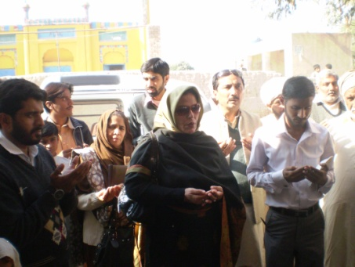
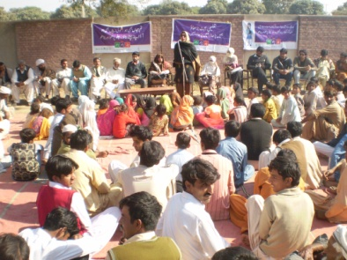

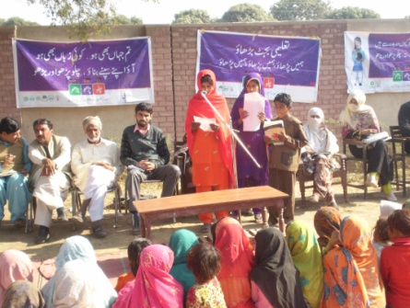
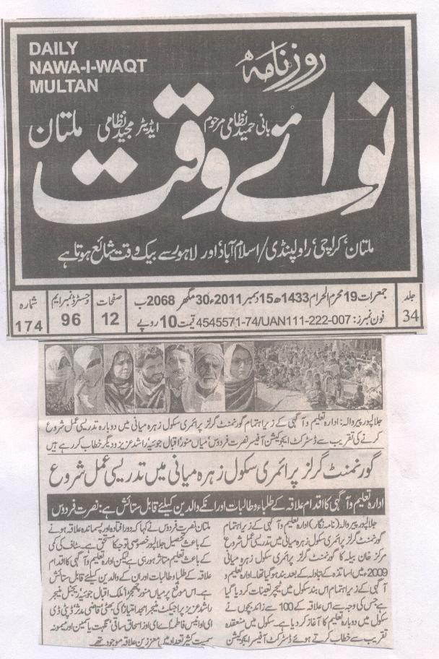

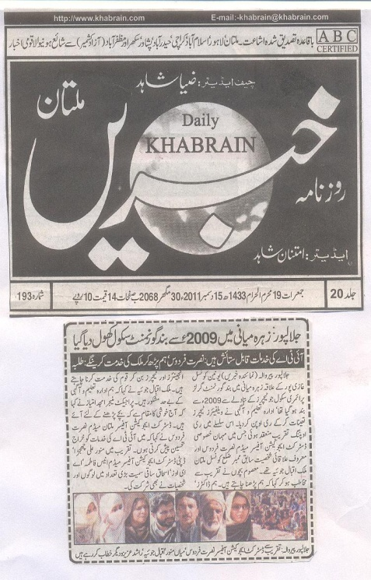

GGPS Basti Baksha School Jalal Pur Peer wala, Multan
Deserted, abandoned, lonely was the school in Basti Bakhsh.Everything in the school was yelling to tell its story to me. It was impatient, hasty description in broken words for what happened with them. Nobody wanted to stay for some time to listen to and take action for them. SCHOOL is nothing for them? EDUCATION is not their benefactor?
Broken walls with construction material, with long grass in the ground was leading us towards scenario in classrooms-wrecked furniture, chipped black boards, windowless cupboards were enough for heart to take a deep plunge in grief.
Neighborhood used the school as a garage for parking their vehivles.With no facility for drinking water, school was a desert with 60 students.
GGPS Basti Baksha School is situated in Anayat Pur Union Council Tehsil Jalal Pur Peer Wala. This school was registered in year 1986 but no teachers was hired. A teacher was appointed in 1992. This teacher taught students for 6 years till 1998.Then again it was closed and reopened in 2002 and again another teacher was hired and that teacher taught till year 2009 and after that school was closed and it was marked as non-functional school.
CPB movement turned the attention of our coordinators towards this school. They, after holding a meeting with the community, provided a para teacher in the school for CPB classes. Condition of the school was improved by initiating health and hygiene program. The changing colors of the school inspired children in the village and strength of the students was raised to 165.
Now the school is happy and smiling.

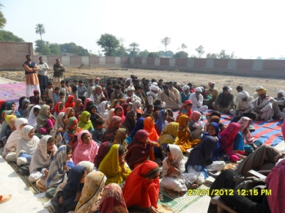
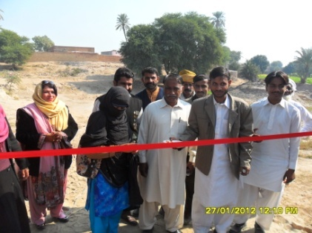

GGPS Zahra Miani Jalal Pur Peer Wala, Multan

Twenty first century- a great panorama of modern inventions and discoveries-is taking plunge into space for other worlds to explore; but look we could not explore schools scattered here and there, abandoned, deserted and closed.
Schools lead the MAN to explore galaxies, space bodies and other worlds above or within us but what if schools are grave yards for dead hopes, thirsty aspirations, staggering ambitions and long, yellow, drooping grass.
Zahra Miani School had been closed for last three years. Most of the villagers are laborers. Cotton and orange is the major production of this village.The teacher got transferred and after that it was left to be a ghost castle .No hope was left for parents to make their children literate. Our team visited the village and their happiness knew no bound when they came to know that their village would have a live school. School was inaugurated by Mz.Nusrat Firdaus.
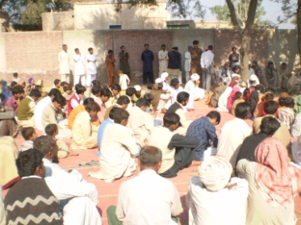
Happiness on the faces of parents and children was beyond words; “school is life. We want life”, I read this in the eyes wandering for hope in the school.
