- Impact of Sanjah Verahs/Case Studies
Transforming lives-Right to Education
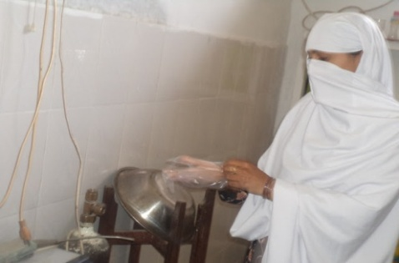
Shabana; a mother of four children was struggling for her life. She wanted to meet both ends by completing a course of Lady Health Worker-LHW; however, being a mother, the responsibility of taking care of her younger kid was one of the major hurdle to accomplish her goal .It was hard to manage home and study side by side in this crucial circumstances. This not only affected her children’s brought up but also her studies as well. Her performance was getting down day by day.
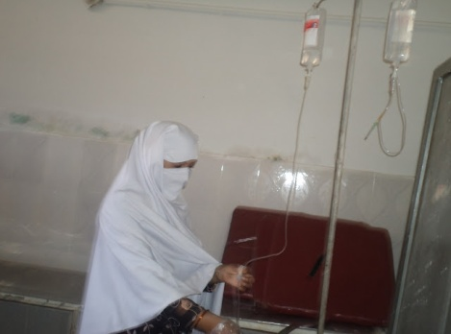
She was living in an area where no day care centers were available for the ease of struggling mothers. When she found no other solution; she decided to take her elder daughter out of school so that she could give a helping hand in household chores and looking after her siblings. As the time passed she realized that her decision was not right. In her struggle she was ignoring her children’s rights like right to education particularly of her daughter. On the other hand, her result was not as satisfactory as she was expecting.
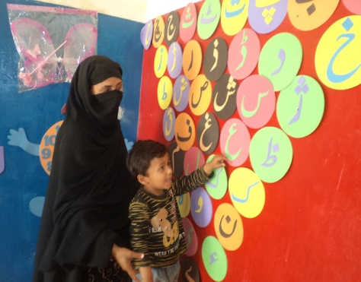
One day one of her friend came to her. She told Shabana that Idara-e-Taleem-o-Aagahi in collaboration with Dubai cares is opening a center named “SANJAH VERAH”, in our locality Basti Malook, where early years children would learn and develop their skills. Sanjah Verah aims at working for Early Childhood Development (ECD).
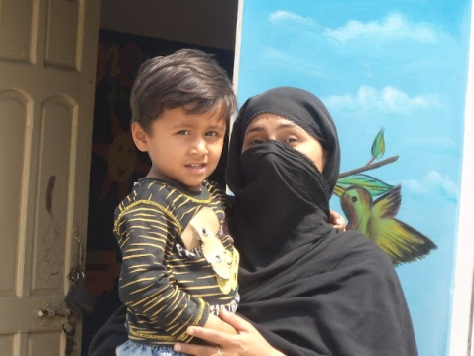
After listening all about Sajah Verah, Shabana’s eyes were twinkling with joy. This solved most of her problems. She got her young son admitted to the Sanjha Wehra and also enrolled her daughter back to the school. This decision made her life easy and she saw an astounding improvement reflected in the Jan-March 2012 term work with 80% marks.
- This Sanjha Wehra not only brought comfort to Shabana’s life but also hundreds of women are getting benefits from SVs. She expressed her feelings of joy by saying, “These centers are 0special gifts for those women like me in rural areas who cannot afford much but desire to improve themselves and their family.”

Colours come in Life………
My name is Nafeesa. I belong to khar family. I live in “laasoori” – a nearby village of tehsil Kot Addu. Due to family and local cultural restrictions, I was not allowed to go out and seek education. But I did not let my desire to get education die, so I did matric and intermediate as a private candidate. Our family does not support education for girls rather women are supposed to be confined to four-walls. So was my destiny. After intermediate I could not continue my further studies and got married.
But thank God, my husband has been quite supportive. When he realized my eagerness for education, he let me do my graduation as private candidate. But the subsequent birth of my two sons, encumbered me with so much domestic responsibilities that the dream for further education seemed to me a far cry.
One such day, I heard an announcement about a community fare from a nearby mosque I went there with least interest. What a great number of women there was! All that knowledge and information came to me, was astonishing to me; some institutions with the help of Government is going to establish a center where the children from 6 months to 4 years would be looked after by trained teachers, this information resurrected my desire for education, while coming to home, I decided to start my studies again.
I shared it with my husband, he was bit hesitant but I convinced him that our children would properly be looked after by trained teachers, and more over the women of our own area would be trained and employed by ITA & DC in the centre. I was very enthusiastic as my dreams were about to come true. I decided to continue my studies and get my children admitted in the centre.
I took much information about it from the teachers of “Saanjha Vehra”, and volunteered myself to teach and support children in the evening session in order to be a dynamic part of this progressive caravan.
Now I am at ease to start my B.Ed program with zeal and zest………..

